CAPACITAR Multicultural Wellness Training
in Healing & Transformation
Sponsored by Capacitar International via Zoom
Facilitators: Patricia Cane, PhD, Capacitar Founder/Director
Joan Condon, MA, Capacitar International Trainer
Sheila Grady, MSEd, Training Coordinator

2023 Training Dates: Saturdays 9:00am – 1:30pm
Module 1: Feb. 04 and 11, 2023 Module 2: April 8 and 15, 2023
Module 3: June 17 and 24, 2023 Module 4: Aug. 19 and 26, 2023

This program is for everyone--parents, volunteer or professional caregivers, community activists,
or anyone who does outreach for the impoverished, homeless, or those with issues of
physical or mental health, abuse, trauma or violence.
CAPACITAR training and techniques can be immediately used and shared.

Training participants will develop:
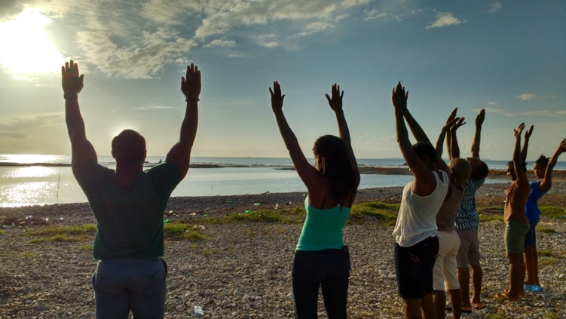
- Wellness skills for living in these challenging times
- Use of CAPACITAR methods in family, community, and professional settings
- Basic proficiency in CAPACITAR wellness practices: Tai Chi, EFT Tapping, polarity, visualization, energy exercises, listening skills, acupressure, and breathwork
- Understanding and integration of theories and methods that form the basis of CAPACITAR work: trauma theory, energy field theory, new cosmology, multicultural wellness, leadership development, healing systems, popular education
- How to use a popular education model to share your knowledge
- A community / global vision and a commitment to personal healing

Cost $175 for Module 1 (includes text and readings)
Modules 2, 3, and 4 are $150 per module or all 4 Modules for $600 (one payment)
Each module of training is a total of 8 hours spread over two Saturday sessions of 4 hours each.
The text, Trauma Healing and Transformation, by Pat Cane, PhD is included and will be mailed to participants.
Additional readings for each module will be sent digitally.
To register and payment information, https://app.donorview.com/nwX5Z

Payment can be by check to our office or by credit card through the link.
Capacitar International 2901 Park Avenue Suite B12 Soquel CA 95073

*Participants should be committed to attend all 4 training modules.
Contact: For more information or an application please contact:
Joan Condon, International Trainer jcondon@igc.org or Sheila Grady, Training Coordinator sgrady@capacitar.org
Capacitar International is a non-profit organization based in Santa Cruz County, CA, with a vision to bring peace, healing and wholeness to our world. Since 1988, Capacitar has worked in over 45 countries and is especially committed to places of poverty, violence, disaster and trauma.
Capacitar is a Spanish word meaning to empower, to encourage, to bring each other to life.
Capacitar’s mission is: Healing Ourselves, Healing Our World. www.capacitar.org

