Keep Calm and Carry On…but How?
Wellness Practices for Self-Care in this Time of Pandemic

Capacitar International Zoom Session
Saturday, March 27, 2021 1:00-2:15 pm PST.
Cost: $25
Click link to Register
Facilitators: Joan Condon and Sheila Grady

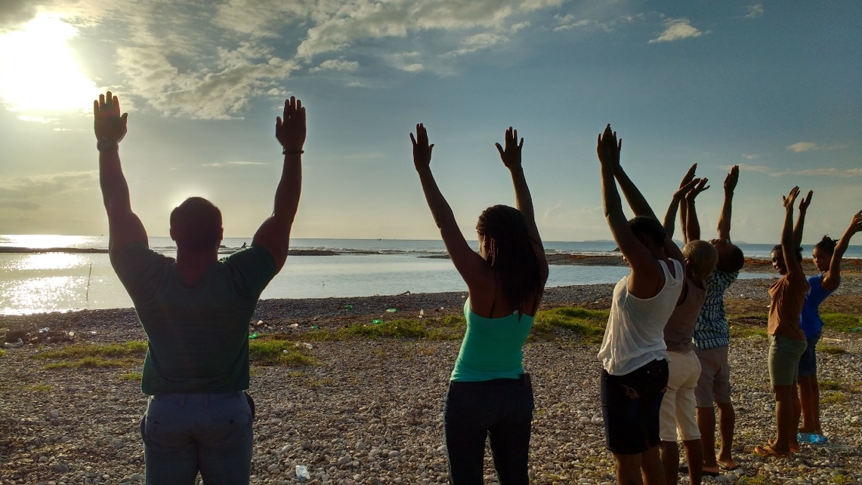

Are you feeling anxious, frustrated, angry, fearful and generally stressed?

Capacitar International offers simple body-mind practices
that can help you feel better in these challenging times.

Learn how to use Fingerholds to Manage Emotions, Tai Chi Movements, Breathing Techniques, Pal Dan Gum and Acupressure to help manage emotions and stress. In our workshops, you will learn by doing.

Healing Ourselves, Healing Our World
The Capacitar International team has shared these tools in over 45 countries in the past 35 years and is especially committed to work in areas of violence and poverty. Capacitar’s mission is Healing Ourselves Healing Our World and its vision is to bring peace, healing and wholeness to our world. For more information visit our website: www.capacitar.org For more information contact: sgrady@capacitar.org

